Data Analytics with Tableau

Name: Mirza Tahseen Raza

Team Member - 4

Assignment -2

Supermarket Sales Data Analysis Report – Tableau Visualizations

- Donut Chart - Sales Distribution by Payment Method
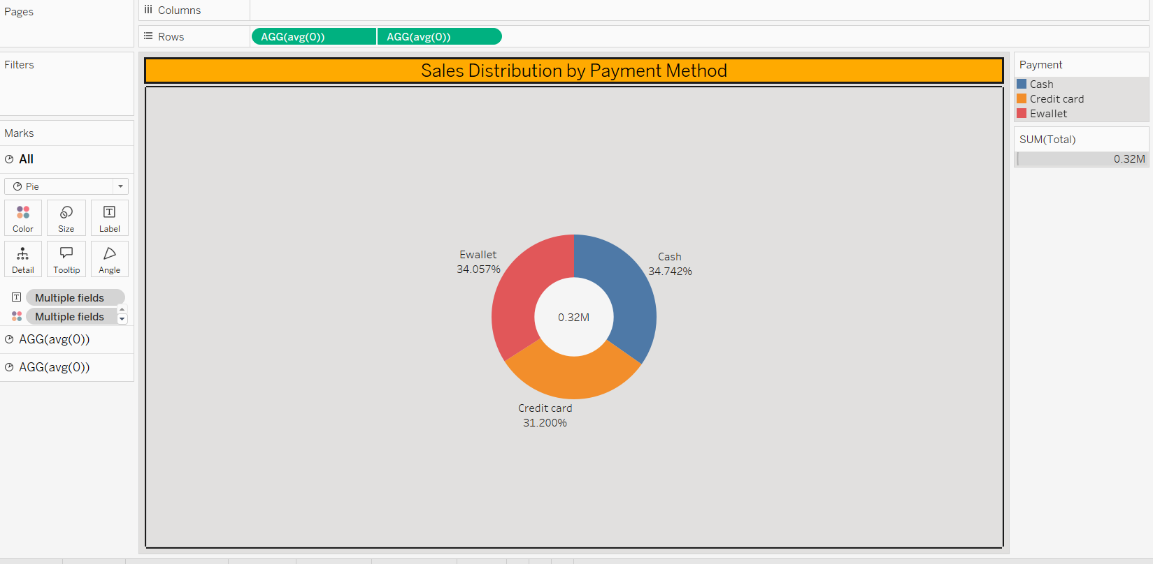
  - Avg(0) and avg(0). For pane Avg(0): Color shows details about Payment. Size shows sum of Total. The marks are labeled by Payment and % of Total Total. For pane Avg(0): The marks are labeled by sum of Total.

- Area Chart- Total Sales Over Time
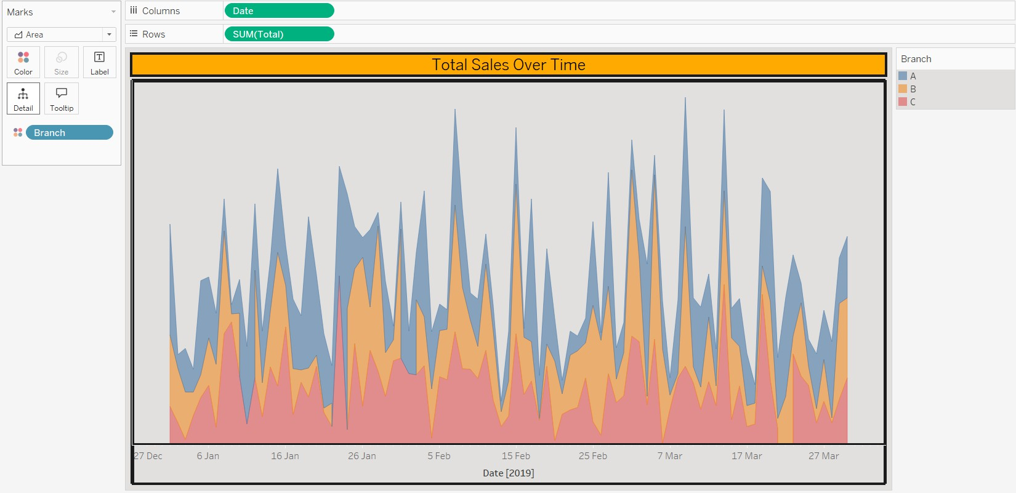
  - The plot of sum of Total for Date. Color shows details about Branch.

- Text Table – Sales Summary by Branch
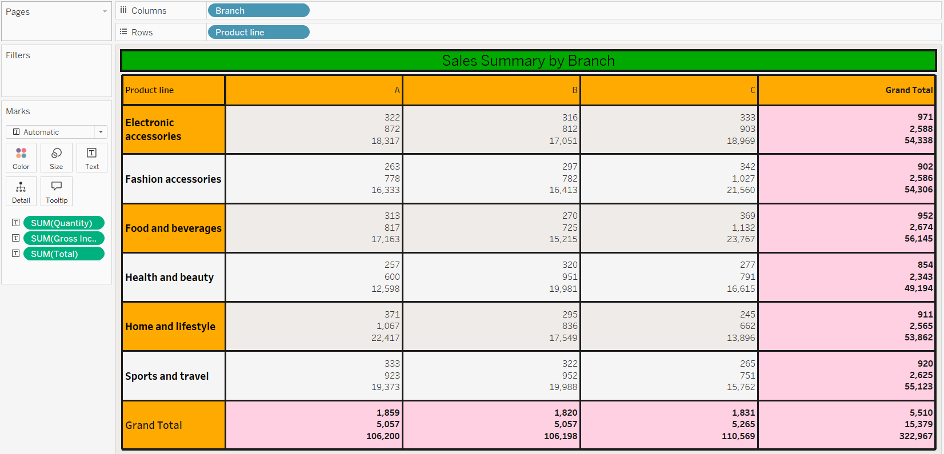
  - Sum of Quantity, sum of Gross Income and sum of Total broken down by Branch vs. Product line.

- Highlight Table – Branch Sales by Product Line
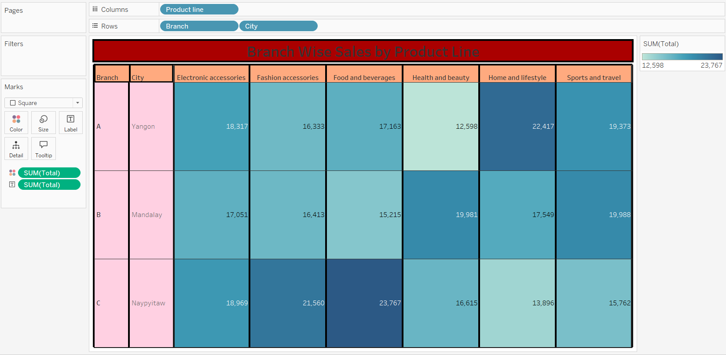
  - Sum of Total broken down by Product line vs. Branch and City. Color shows sum of Total. The marks are labeled by sum of Total.
- Word Cloud – Frequently Purchased Products

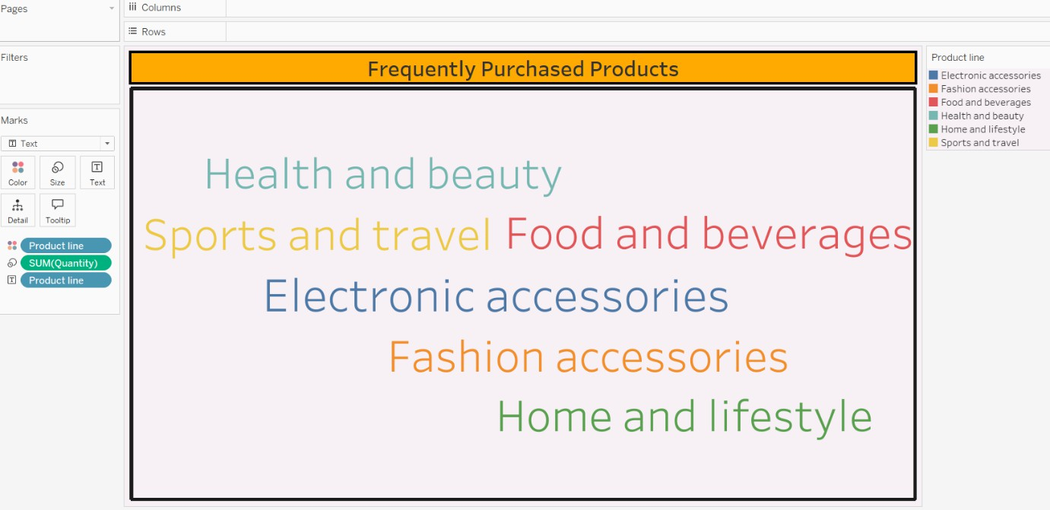
  - Product line. Color shows details about Product line. Size shows sum of Quantity.

- Funnel Chart – Total Sales by Payment Method
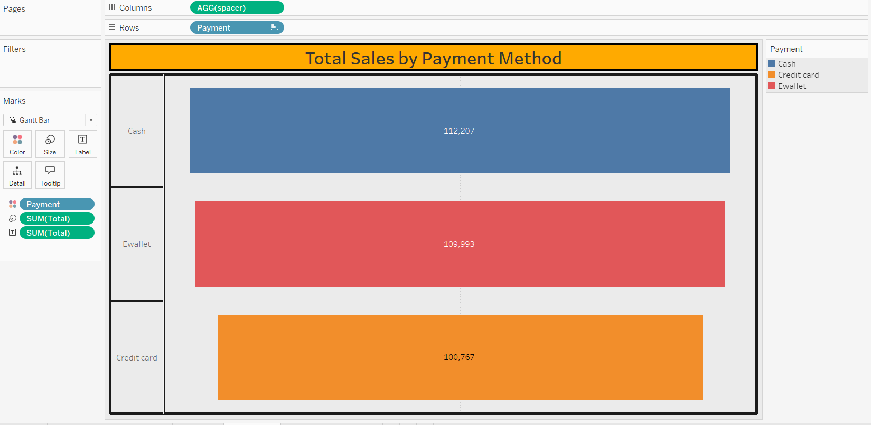
  - Spacer for each Payment. Color shows details about Payment. Size shows sum of Total. The marks are labeled by sum of Total.

- Waterfall Chart – Total Sales Contribution by Payment Methods

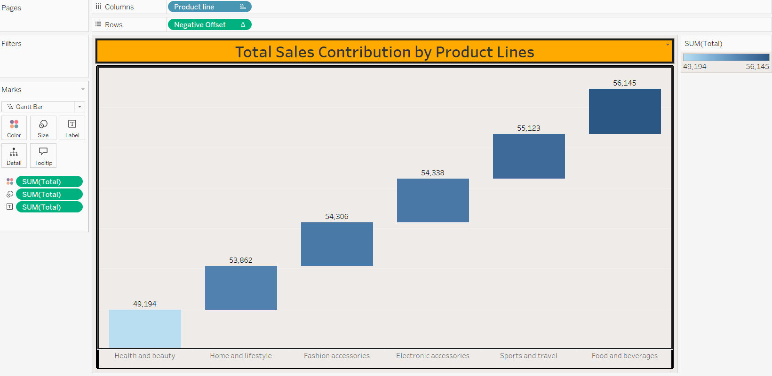
  - Negative Offset for each Product line. Color shows sum of Total. Size shows sum of Total. The marks are labeled by sum of Total.

